**Guidelines for running PHP, MySQL**

**1. Running HTML and PHP code**

Please instructions from following link to setup and run sample PHP code.

<http://www.tutorialspoint.com/articles/run-a-php-program-in-xampp-server>

**Note:** when you write “localhost” in the browser, it will automatically load index.html. or index.php, or home.php etc as these files are listed in “httpd.conf” found at C:\xampp\apache\conf as starting file. If you have any file name index/home/default etc, please rename them to something else to see all files in the folder. Otherwise localhost will load index/home/default file and you must create links to other files in the code of index/home/default to access them.

Go to <https://www.w3schools.com/php/default.asp> and try running examples in your local machine as explained in the above link.

For example, to run if-else code from w3schools, go to the example (https://www.w3schools.com/php/php_if_else.asp) -> click on run example,

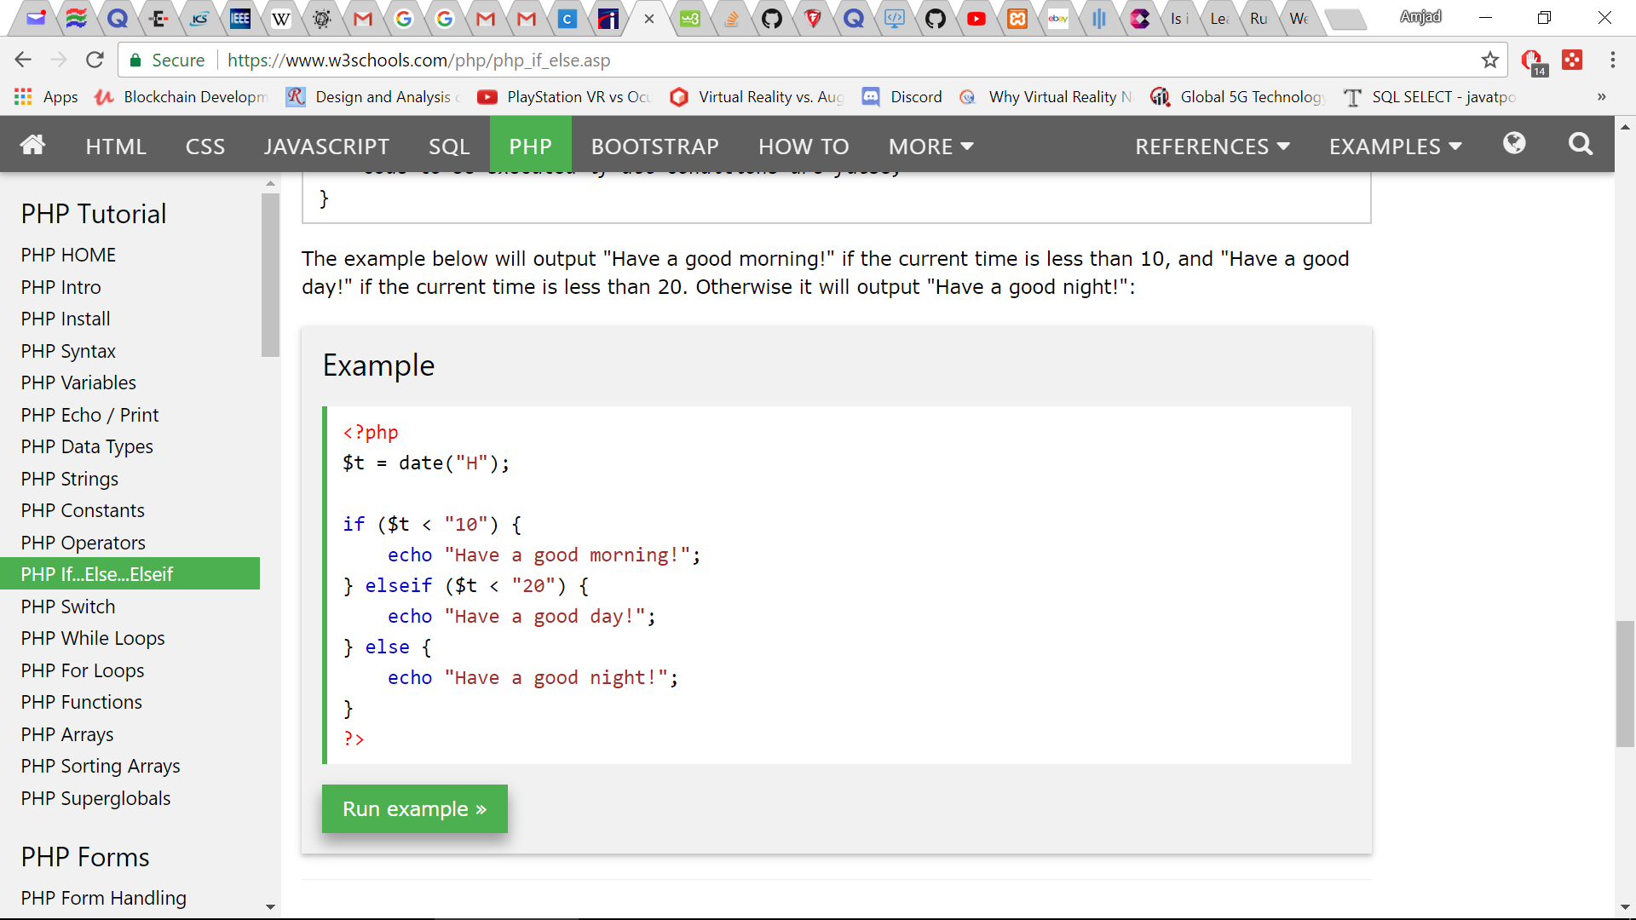



It will show you complete code (html and php both) at left side with output of the page at the right side as shown below:

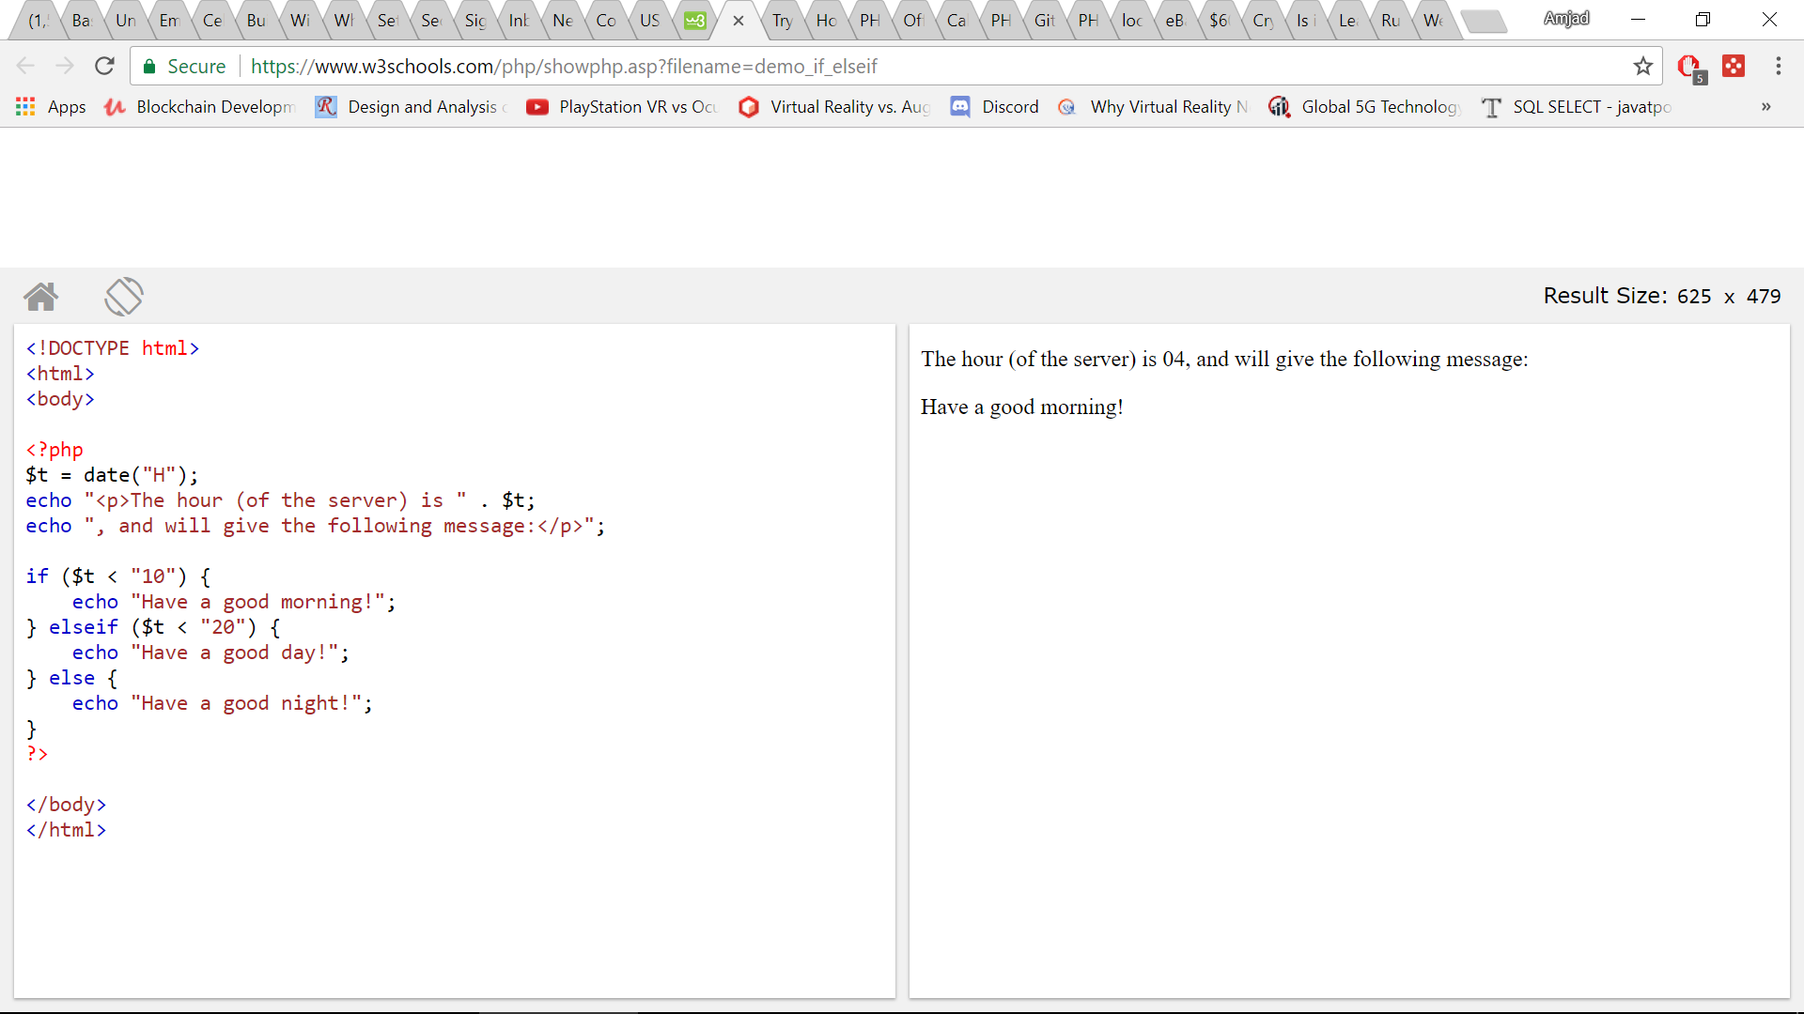

To run the code in your local machine just copy this complete code and paste in a file in C:/xampp/htdocs, say “ifelse.php”. Please make sure that you keep file extension “.php”. Now if you go to localhost again, you should see this file. Click on the name you should see the same output as you can see at the right side of the above image.

**Practice as many php example codes as possible from the W3Schools. At this point you are ready to run php to access database.**

**2. Running PHP, MySQL on your local machine/laptop (Assuming you already have the university database in your local mysql server):**

1. Create a folder say “temp” in your c:\xampp\htdocs folder. Put the given files in there. Now change “dbconnect.php” file as instructed in that file.
2. Now in browser, type “localhost/temp”, it should show all the files. Click on them to execute one by one.
3. You should try to understand the code when you are executing them. Start from “ dbconnect.php”, then “listtables.php”, “tableshow.php” and then “insert.php”.

If you understand above codes (not hard to understand) , then you are ready to run any queries on the database from PHP. Read the following summary about the given files:

dbconnect.php”, - connects to the database by given username, dbname, password and servername. Other three files imports “dbconnect.php” to make connection to the database and perform different operations.

“listtables.php”, - lists all the tables in the currently connected database.

“tableshow.php” – the function displays the content of the instructor table of the university database (select query)

“insert.php” – insert a record in the instructor table of the university database (insert query).

**3. Running PHP, MYSQL on CS server (dbdev.cs.kent.edu – apache, PHP, MySQL are already installed)**

1. SSH to dbdev.cs.kent.edu. Go to public_html
2. Create a folder say “temp” in your “public_html” folder. Put the given files in there. Now change “dbconnect.php” file as instructed in that file.
3. Now in browser, type “dbdeb.cs.kent.edu/~your_flashline_username/temp”, it should show all the files. Click on them to execute one by one.

If you want to can also run php, MySQL on Amazon Web Servers. Please refer instructions in “Running PHP on AWS.docx”